Fire Fuels Mitigation Sampling Protocols – 2022

# Preparation

1. Use site maps located in: **F:\Data\RESEARCH_DEMONSTRATION\RESEARCH PROJECTS\BerrillJonesYork GHG Fire Fuels Mitigation Forest Wide\Maps\Field Maps**
2. Refer to FIREMON protocols, pages 116-140: <https://www.fs.usda.gov/rm/pubs/rmrs_gtr164.pdf>
3. Plots are the fuzzy purple circles. Number them from west to east, and north to south (like reading a book).

Example: 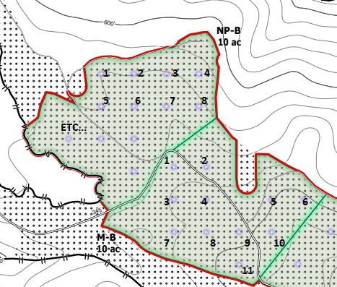

1. Bring the following to the field:
   1. Datasheets
      1. Fuels
      2. Regen
      3. Trees
      4. Paper map of site
   2. Site map on Avensa
   3. Clipboard
   4. Pencils
   5. Tree tags
   6. Reference tree tags
   7. Ball point pen (for writing on reference tags)
   8. Hammer
   9. Nails (a lot)
   10. 3 metric cloth tapes
   11. Metric logger’s tape (one per person)
   12. Metric Biltmore stick
   13. Go/No-Go metal fuel size gage
   14. Metal ruler
   15. Compass (one per person)
   16. 4 chaining pins
   17. Pin flags
   18. PVC poles
   19. Rebar (short and long)
   20. 2 Laser range finders
   21. 2 hypsometers
       1. Transponder
       2. 360-degree adapter
       3. Monopod (one-legged tripod)
       4. AA batteries

# Set-up

1. Choose plot:
   1. Choose 5 plots per unit that are evenly spread throughout the treatment unit (example of unit is Dunlap M-NB).
   2. Navigate to center of fuzzy purple circle (plot center) on Avensa map.
   3. Reject site if ~~about~~ 50% or more of it is skid trail (aim for at least 10 trees).
   4. If plot is rejected, note on paper map why plot was rejected.
2. Set up plot:
   1. Use short rebar if the unit has a mastication prescription. Otherwise use long.
   2. Drive rebar into ground at plot center (flush with ground if in mastication unit).
   3. Place PVC pole over rebar and hammer it into place.
   4. Put bent pin flag in top of PVC pole (remove it temporarily when using compass to set up transects).
   5. Place chaining pin into ground next to PVC pole.
   6. Use compass to set up three transects with cloth tapes at 0°, 120°, and 240° angles from plot center (aim for within 2° accuracy). Stretch cloth tapes to 11 meters long or more. Fix in place with chaining pins.
   7. Transects can go over low stumps but must be offset if tree is in the transect. Note the **azimuth** used for the transect on “Fuels” datasheet when offset is necessary.
   8. Record **percent slope** for each transect line.

# Data Collection

1. Fuels Data
   1. On the Fuels datasheet, write **Site name**, **Treatment** (NP-NB, NP-B, M-NB, M-B, LS-NB, LS-B), **Plot** **#,** **Date**, and **Crew member** next to the task they are doing.
   2. 1 square meter cylinders, 2 meters in height, will be used with center points at the 10-meter mark and 5-meter mark on each transect tape. Write in **10m** and **5m** for “meter mark” on datasheet. Add a line down % Litter column and add a “FBD” (Fuel Bed Depth in cm) column.
   3. For each of these (visualized) cylinders:
      1. Measure **Duff+Litter height** in cm using metal ruler – choose an average spot within the 2m diameter cylinder to take measurement
         1. Note: moss is litter
      2. Estimate **% Litter** from the Duff+Litter height
         1. Note: Duff is decomposing, darker material
      3. Estimate **FBD** – an average Fuel Bed Depth of the cylinder.
         1. Do not forget the cylinder extends 2 meters in height.
         2. Fuels that count for FBD are: Dead woody fine and coarse fuels. Fine woody (up to 100 hr fuels) count if they are standing dead
         3. Fuels that do NOT count for FBD are:
            1. Coarse (1000 hr) fuels that are at angled 45° to upright (often stumps),
            2. Dead attached to live fuel,
            3. Duff (though litter counts toward FBD),
            4. Bark and cones
      4. Estimate **Live woody %** (0%, 0.5%, 1%, 3%, 10%, 20%, 30%, 40%, 50%, & etc. by tens).
      5. Estimate **Dead woody %** (this is dead woody vegetation that is attached to live woody vegetation)
         1. Refer to image for examples:

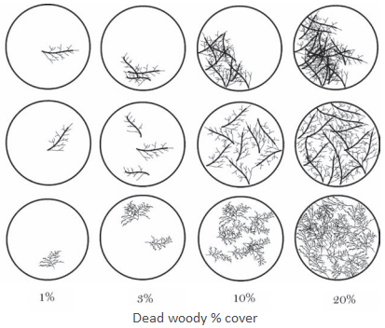 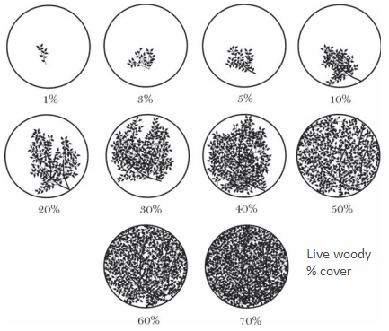

* + - 1. Note that thick lines in above examples are 1” diameter stems and thin lines are ¼” diameter.
      2. Be mindful of cylinder height. Consider woody material up to 2m.
    1. Estimate average **Woody Height** of live and dead.
       1. Imagine a cloth is draped on all rooted fuels and litter – what is the average height of the cloth?
    2. Estimate **Live and Dead Herbaceous % cover separately**.
       1. Herbaceous: and blackberry are considered herbaceous along with grasses and other typical herbs
       2. Not Herbaceous (woody): salal, huckleberry, rhododendron, manzanita, brooms, poison oak, and other shrubs and trees
       3. Not Herbaceous (other): Moss is not considered herbaceous, but is counted in litter estimates
    3. Estimate average **Herbaceous** (live and dead) **Height**.
    4. **Count** **1 hr**, **10 hr**, **100 hr**, and **1000 hr** fuels using Go/No-Go gage
       1. Choose a side of the tape to measure from and stay on that side for the entire transect.
       2. 1 hr ≤ ¼” ≤ 10 hr ≤ 1” ≤ 100 hr ≤ 3” ≤ 1000 hr
       3. Measure 1 hr fuels between 10 meters and 9 meters along transect
       4. Measure 10 hr fuels between 10 meters and 8 meters along transect
       5. Measure 100 hr fuels between 10 meters and 6 meters along transect
       6. Measure 1000 hr fuels between 10 meters and 0 meters along transect
       7. See graphic:

* + - 1. For 1000 hr fuels (coarse woody debris), measure the **diameter** and estimate the **decay class**:

* + - * 1. Diameter can be measured with diameter tape even for oddly shaped 1000 hr fuels.
        2. Make your best judgement call whether fuels are one or multiple pieces when they are broken. Think of how it would burn.
      1. Fuels do not count if buried in duff (pith is in duff layer).
      2. Pith must cross tape to count the fuel.
      3. Pith can cross tape multiple times and be counted multiple times.
      4. Tip of log is not counted if pith does not cross tape. See graphic:

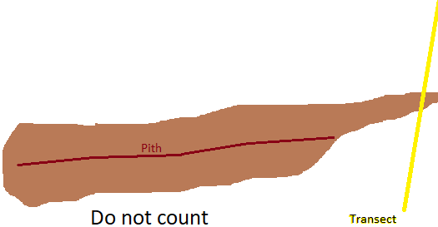

* + - 1. Bark and cones are not counted.
      2. Redwood has feathery leaf sprays. Count twig of RW if ≥2mm in diameter. Ignore <2mm sprays since they are not significantly woody. See graphic:

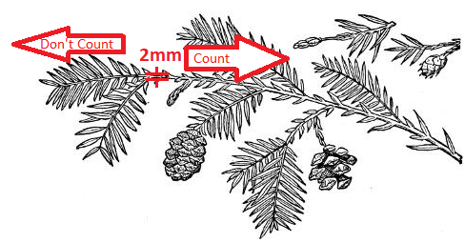

* + 1. Take any pertinent notes on Fuels datasheet. More notes = better!

Fuels Datasheet:

1. Regen Data
   1. On the Regen datasheet, write **Site name**, **Treatment** (NP-NB, NP-B, M-NB, M-B, LS-NB, LS-B), **Plot** **#** (in column), **Date** (specify next to column, or notes section if data taken on different dates), and.
   2. Count the number of **Seedlings** within a 5.64-meter plot radius (1/100th of a hectare) centered on plot center.
      1. Seedlings are tree species that are below breast height.
      2. If the seedling is not growing vertically, stand it upright to determine whether it is a seedling or sapling.
      3. Height is measured from the ground (rather than the top of a stump if the tree is growing from a stump)
      4. Record seedlings by species using dot-and-line tally in the column “<BH”.
      5. Use the hypsometer (after calibrating) to determine if seedling is in or out of 5.64-meter plot. Place transponder at plot center with 360-degree adapter.
      6. Seedlings are separate if they are growing individually or from the same root collar.
   3. Count **Saplings** by diameter class within a 11.28-meter radius (4/100th of a hectare) with center at plot center.
      1. Use dot-and-line tally by species and centimeter diameter class (0-2.5, 2.5-5, 5-6, 6-7, 7-8, 8-9, 9-10).
      2. Using the laser range finder, measure the base to live crown and height of the first sapling measured of each species in each diameter class. If the sapling has significant defect or is significantly leaning, measure the next sapling.
      3. Height is counted from the ground, not the stump if growing from stump.
      4. Stems greater than 10cm at breast height are considered Trees, not Saplings, and are recorded on the Tree datasheet.
      5. It is convenient to use a calibrated hypsometer to check whether a sapling is in or out of the 11.28-meter radius plot.
   4. Add any pertinent notes.

Regen Datasheet:

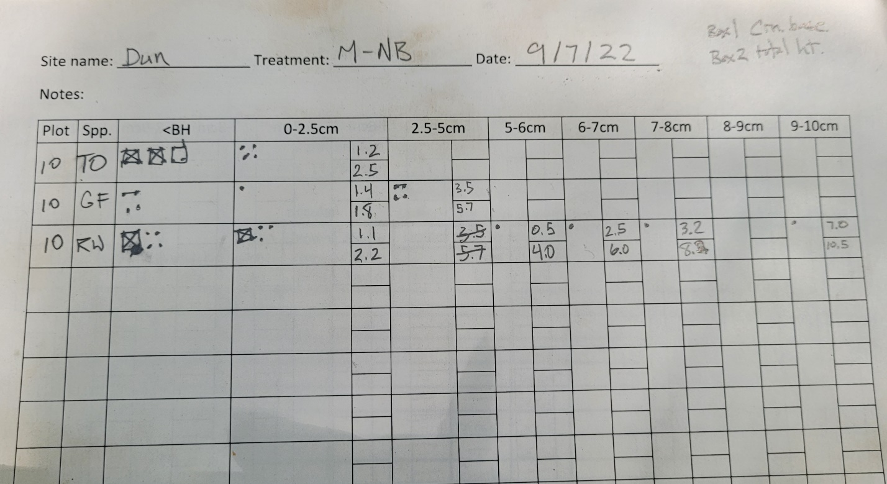

1. Trees Data
   1. On the Trees datasheet, write **Date**, **Block** (Treatment) - **Plot** **#**, **Site Name**, and **Crew members**.
      1. Aspect is the azimuth that the slope is facing. It can be thought of as the direction that water would travel.

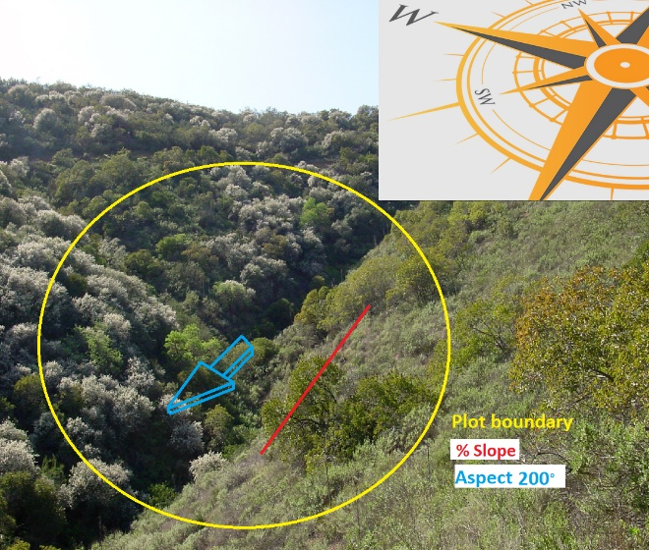

* 1. Tag trees (≥10cm DBH) starting at 0° from plot center and working your way clockwise within a 11.28-meter plot radius. Nail tags in at DBH (measured from uphill side of tree), with tag facing plot center.
  2. For each tree, record:
     1. **Tag** **#**,
     2. **Species**,
     3. **DBH** (from uphill side – use Biltmore stick if you cannot use D-tape),
     4. ~~Height,~~
     5. **Crown to base Height**,
        1. Measured from base of tree to lowest continuous crown that is representative of the tree’s crown
        2. Can be negative value, but record negative values as zero
     6. ~~Crown ratio~~
     7. **Same Clump Tag #**,
        1. If trees are in a clump (RW or TO), then list the other trees within that clump.
        2. RW are clumped only if they are in close proximity. Old growth fairy rings are not considered clumped.
        3. Tanoak stems that fork below breast height are separate stems if they are co-dominant or intermediate.
     8. **Defect** by location – split tree into thirds.
        1. If the tree has a broken top, estimate the location where the tree broke (top, mid., or bottom third)
        2. See defect codes in datasheet. Also use “LDS” defect code for RW with Large Dead Sprout (≥10 cm branch that will scar).
        3. Tanoaks have splits in bark. Count it as a scar if the cambium is exposed. If it is healed, do not count it as a scar.
        4. Scar vs cavity – it is a cavity when the exposed wood rots, or burns.
        5. If the lean is less than 60° (horizontal is at 0° and vertical is 90°), record the average tree lean in the notes: “lean:45°”
        6. Forks – if the stems of conifers are co-dominant or intermediate, count it as forked, ignore forking in hardwoods.
     9. Some sites have a lot of **dead crown** down the length of the trees. If your plot is in this type of stand, record in the notes for the Tree datasheet. Only record it if dead crown generally extends down the tree to within 2 meters of the ground. Note about where the dead crown starts (1/2 meter from the ground, for example). Reserve dead crown notes for trees whose dead crowns have many fine (<1/4”) branches.
     10. **DBHs of <10cm clump trees**
         1. List the DBHs (rounded to nearest cm) for saplings that are clumped with the tagged tree.
     11. Take notes in “Notes” column as needed
     12. Tag two **reference trees** (favor larger, vigorous conifers closer to plot center)
         1. Tag with the blank reference tags. Use ball point pen to record on reference tag: **tree tag #**, and **horizontal distance** and **azimuth** to plot center. Nail tag to the base of the tree.
         2. Record the tree tag #, distance, and azimuth in Tree datasheet.

# Data Management

1. Every week or two, scan datasheets and paper maps in batches (all in one file).
2. Email scan file to Jud: [jf225@humboldt.edu](mailto:jf225@humboldt.edu)
3. Store paper originals in designated place in office.